Mindtree
- What is dyna action in struts
- What is dispatch action
- Difference between hash map and hash table
- What is synchronization
- What is serialization
- Difference between equals and hash code overloading (what do you mean by each of them and why both are required)
- What are UML diagrams and explain different types
- Explain aggregation, composition, delegation and inheritance
- Explain Multithreading
- Explain differences between jdk1.4 and jdk 1.5 (Explain Annotations & Generics)
- Difference between ArrayList and Vector (min 3 nos)

HP
- What is dyna action in struts
- What is synchronization
- What is serialization
- Difference between equals and hash code overloading (what do you mean by each of them and why both are required)
- Explain Multithreading
- Can a normal bean be used instead of an ActionForm in struts, if yes, then, how
- Explain the creation of a custom tag in jsp & struts
- Difference between throws Exception & throws Throwable(adv and dis-adv of both)
- How to load a class during runtime; explain different approaches used for this.

EMC²

- What is dyna action in struts
- Difference between hash map and hash table
- What is serialization
- What are UML diagrams and explain different types
- Explain aggregation, composition, delegation and inheritance

Polaris

- Difference between Hibernate & other ORM technologies
- Explain JSTL
- Explain the creation of a custom tag in jsp & struts
- Explain differences between jdk1.4 and jdk 1.5 (Explain Annotations & Generics)
- What’s new in Struts 2.0

CustomerXPS

- One big file with 2GB contents (one int per line – unsorted). RAM is 1GB and hard disk is 80GB. How to sort it.
- Re-arrange the contents in an Array such that all odd numbers will be in the odd index and all even numbers will be in the even index
- In a 4x4 chess board, how many queens can be placed without intersecting one-another. The number as well as the approach.

HCL

- Can we connect to two different types databases at the same time using hibernate? (eg: 1 sql server and 1 oracle)
- Can we define two different struts action servlets in a single web.xml file? Will it give any errors, if so, which type, technical / functional
- Explain comparable and comparator interfaces
- Explain object cloning & its uses
- Explain delegation
- How to overload exception framework
- Difference between equals and hash code overloading (what do you mean by each of them and why both are required).Why it is overloaded by default in JCF (Java Collections Framework)
- What are the default functions available in the Object class
- Explain life-cycle of the request in Struts
- Explain Hibernate and why it is used in the project
- Explain different types of validation in Struts
- Explain RegEx and give some examples
- Explain the different types of variable scope available in Struts
- What is serialization
- What is hash set (how to sort an array and remove duplicates)
- Explain any XML technology in Java apart from DOM
- Explain Singleton Design Pattern
- If an element is removed, what happens to the size of the collection
- String is said to be immutable, why, explain
- Explain hashing
- Explain the use of hash code
- How to define a PK-FK relationship in hibernate bean and mapping files
- Is the session object in hibernate thread safe
- Explain delegates.

IBM

- Explain design patterns in Java (any 2 in detail with eg.)
- What is serialization
- Explain Struts framework, MVC – explain the request lifecycle
- Explain working of Hibernate (how to create a small hibernate application – steps)
- Difference between hash map, hash table and hash set, which is desirable
- OOPS Concepts, how aggregation is related to inheritance
- Explain Multithreading
- Difference between final, finalize and finally
- PSV main, how it is executed
- Difference between Arraylist and Vector and which is desirable
- JDBC connection – steps involved
- Difference between Callablestatement and PreparedStatement
- Explain differences between jdk1.4 and jdk 1.5 (Explain Annotations & Generics)
- What is the servlet call made when calling an actionservlet and by whom.
- Which service or class is responsible for reading web.xml of a website.
- What is the difference between WAS and WPS.
- What is a process and why it cant be deployed in websphere application server.
- Which one will you use for an object collection, a list or arraylist and why.
- Difference between DOM and STAX parser and which one is preferred.
- Struts flow.
- Difference between struts 1 and struts 2.
- What is a cursor and explain adv and disadv of it.
- How to create custom validation framework on top of struts validation framework
- Write a program for an application which has 2 threads and a shared resource
- What is a marker interface and write a program to show its usage
- Explain singleton pattern with a program
- What is caching and how to implement it

Ocwen Financials

- Explain DB Normalization – with eg
- Explain OOPS concepts
- In Struts, how can we make a class to be called from jsp before any of the actions
- Explain serialization and why it is required
- Hibernate connection steps

Oracle

- How to create an XML parser, which data structure to use and logic to traverse.
- Difference between SAX and DOM parser.
- Which Application server have you worked on and the difference between WAS and WPS.
- How to create and deploy a new process in WPS.
- Serialization and de-serialization and how to make a class serializable, also how to transmit the serialized class info via network.
- What is SOAP and how it’s different from HTTP.
- How to convert a single linked list to a circular linked list.
- Difference between tree and binary tree.
- How to traverse to the middle element of a linked list in a single iteration.
- How to create a linked list in java apart from using the collection framework as pointers concept is not present in java.
Huwai

- Connection Pool, write a program to create a pool of 5 connections which will extend the pool size when required by a step of 5.
- What is singleton, implement a fiveton class (similar to singleton, but 5 instead of 1).
- How to make a program synchronized. (a program with lots of confusing set of collections given)
- Write a program to get the greatest prime number for any given no.
- Write an algorithm for selection sort.

ACI / V2Soft

- Difference between set / hashset / list / arraylist / linkedlist
- How to configure 2 diff databases in one hibernate project
- Syntax for one-to-many and many-to-one mappings in mapping file
- How to create composite primary key in hibernate
- Difference between encapsulation and abstraction.
- How to select 100th to 200th row from a table with 500 records
- What are projections in hibernate
- Functions in object class
- Difference types of actions
- Explain validation framework in struts and how to customize it for using custom validations
- Explain final, finalize and finally
- How to restrict number of rows retrieved using hibernate
- Different types of jsp tags.
- Difference between == and equals for string

enStage

- How to replace a char(multiple occurrence) in string without using arrays / replace / replaceAll methods
- Difference between set / hashset / list / arraylist / linkedlist
- Write code for synch method and how two threads call this
- Sql for 2nd highest sal from emp table with duplicate sal without using row_number / rowid
- Inheritance, abstraction, encapsulation and polymorphism with examples
- How arraylist functions internally
- What is jpos
- Write a program to remove duplicates from a list and sort it

iGate Patni

- Difference between high and low level designs
- Explain or differentiate between UML, Class & data flow diagrams
- Steps involved in implementing cache framework in your application
- Different types of documents that are used during requirement gathering phase
- How to estimate timelines for your project(general estimation and not by using custom estimation templates)
- Explain DAO
- Explain DTO
- Explain MVC & controller in particular
- Explain different types of design patterns and how you’ve used it in your project
- Difference between dispatch & dispatchlookup action in struts.

Fidelity

- Explain life cycle of a struts application and how jsp/html is routed even though no config exists for them in web.xml?
- Difference between block and method synchronization
- Difference between MVC1 and MVC2
- Explain struts validation framework and diff types of validation that can be done using struts, is there any client side validation available in struts??
- What is serialization and why do we use it? How it transmits data & state?
- What are the different ways in which processes / programs can communicate
- Difference between jdk 1.4 and 1.5, explain annotations in detail.
- Is there any particular type of object for storing elements of HashMap other than using generic objects?
- Types of normalization with an example for each
- What is singleton pattern and steps involved in making a class a singleton
- What is façade pattern, give an example
- How to select 6th highest sal from emp & dept table in oracle
- Can we have functions in jsp, if yes, how to access them from a scriptlet
- Explain different type of struts specific tags and their usage
- What is Swift & how does it function, also explain different types of messages used in the process
- Explain any one scenario for Swift E & I
- IRCTC booking doesn’t support seat selection before payment. If you were to implement that functionality, what are the approaches that you might use and explain why
- How do you plan to start a new development(new project, new tech), what are the steps that you might find necessary
- What are the differences between waterfall and agile methodology and which one do you prefer for a banking project where in the requirements rely on guidelines laid out by some national / international organization
- There’re 2 tables, emp(id, name, deptid, sal) & dept(id,name)
  - How do you select the dept name in which max no of employees work
  - How do you select the dept name which has the employee who earns the most
  - How do you select the dept name which has the employee who earns the second lowest salary provided no 2 employees have the same salary
  - Can you optimize this design and if yes, how and what is it called
- What is indexing and explain how it’s done in any one DB
- What is stored procedure and why it is used
MeritTrack
- Which all design patterns have you encountered in your last project excluding the ones used in framework
- Explain factory pattern
- Explain Façade
- Explain Singleton with steps to create one and why each and every steps are required
- How multiple threads in the same JVM communicate with each other
- How you can handle inter process communication in Java

Thomson Reuters
- What is Marker Interface and where it’s used and why
- Composition & Aggregation
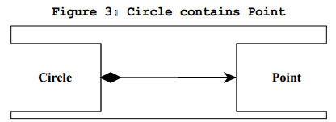
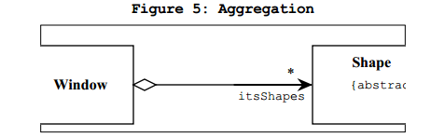
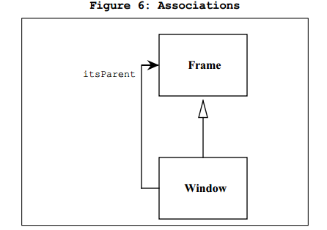
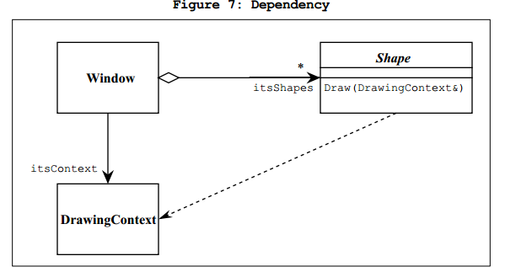
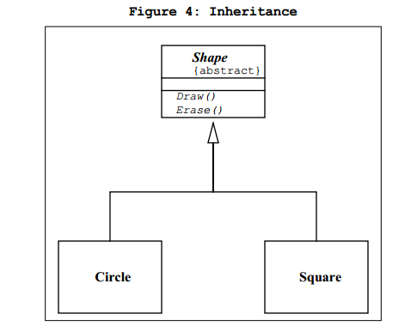
- Pass by Reference in Java w.r.t a program
- In UML, what is the difference between “is” and “has by” relationship
- How hash map works internally
- Design patterns used in your project and why no other pattern in that particular scenario
- Which all documents are handled by you, how many technical and how many managerial
- Reporting structure of your team and how it fits in Agile methodology of handling changes
- How impact analysis is made for any change requested by the customer
- Life cycle of JSP
- How struts work
- How to do validations in struts(diff approaches and their respective merits)

Crimson Logic
- Solve Tower of Hanoi simulation as well as write a program to do so for n number of disks. Write it in recursive way as well.
- Tell the output of the following program and whether both are possible or not with explanation of why it’s not
package test;

public class test {

public static void main(String[] args) {
A a=new B();
a.abc();
A objA=new A();
objA.abc();
// B b=(B) new A();
// b.abc();
}

}
class A{
public void abc(){System.out.println(1);}
}
class B extends A{
public void abc(){System.out.println(11);}
public void def(){System.out.println(22);}
}

- What is the output of the following program and why
package test;

public class test2 {
public static void main(String[] args) {
A1 objA=new A1();
objA.print();
B1 objB=new B1();
objB.setDetails(objA);
objA.print();
}
}

class A1{
int id=1;
String name="0";
public void print(){
System.out.println(id+"-"+name);
}
}
class B1{
public A1 setDetails(A1 objA){
objA.id+=objA.id;
objA.name+="-"+objA.name;
return objA;
}
}

- What is Agile methodology and how it is used in your project
- What is MVC and how struts is using it
- How to create a custom exception framework which supports the following
- Auto resume
- DB / File / Console Logging
- Dynamic updates to the severity of different exceptions
- Independent of the core code
- Configurable logging format on the fly
- How many types of joins are there and what is left inner join ☺
First Financial Bank
- What are the possible errors this program might encounter.
public class testInt1 extends Base{
public static void main(String[] args) {
this.newPrintMethod();
super.printMethod();
}
public static void newPrintMethod(){
System.out.println("Child class newPrintMethod");
}
}
class Base{
public void printMethod(){
System.out.println("Base class printMethod");
}
}
- What is the output of the following program
public class testInt2 extends Base{
public static void main(String[] args) {
String strTest="Hello";
strTest.concat("World");
strTest.toUpperCase();
System.out.println(strTest);
}
}
- Identify errors in the following program

public class testInt2 extends Emp{
public static void main(String[] args) {

}
public static void printEmp(final Emp empObj){
empObj=new Emp();
empObj.name="jithu";
}
}
class Emp{
int id;
String name;
}
- Write for loop for pre and post java 1.5

MindTree

- Explain project architecture
- How is error handling done in your project
- What is the technical problem that you’d solved which you feel is an important accomplishment in your career
- Any one design pattern that you’ve used in your project and why did you choose it for that particular situation
- Leadership questions with different scenarios and how you’ll be approaching them

Emids
- Why design patterns are required and which one you’ve used in your project other than creational pattern
- If there’s an employee table with salary, employee and manager id as columns, how to select the manager who’s employees are drawing the highest salaries
- Why ORM is required and the advantages of using Hibernate
- How caching is done in Hibernate
- What is lazy loading w.r.t hibernate
- How to implement singleton pattern in different ways(implement lazy loading)
- Why double locking is required in Singleton
- Why public static variable is not used instead of getInstance() method in singleton

JDA
- 2 blind guys bought 12 pairs of socks (6 pairs of black and 6 pairs of white) from a shop and on the way out, they collided with each other and the socks got mixed up. How can they get exactly the same amount of black and white socks without the help of anyone else?

Wells Fargo
- What is serialization and why do we do that
- How to serialize a class and what format can it be written to
- What is transient and how it is handled during serialization
- How to write an object to xml and get it back
- How static variable will be treated during serialization
- What is called as immutable and how to make a class immutable
- What is synchronization and how locking works internally
- Different ways to create thread
- If we have 2 objects of a class and a method in the same class is synchronized, then how both objects will access the method
- When a thread finishes with the code in run method, then what it will do
- Different ways to synchronize code
- What is a concurrenthashmap and why it is used
- Diff between concurrenthashmap and hashtable
- How is data stored in a hashmap internally with diff steps involved
- Can a java program have same hashcode returned for diff objects with equals returning false
- What’s the contract between equals and hashcode in java and what are the issues arising on not following the same
- Architecture of your project
- How dependency injection is used in your project(framework-project scenario)
- Types of frameworks used for UI dev
- How project is deployed(in same JVM ya diff) and in which application and web server

SLK Software
- Difference between String and StringBuffer
- Difference between HashMap and ConcurrentHashMap
- What is Hibernate and why is it used(list out major advantages)
- Explain different ways to swap two numbers
- What is called inversion of control w.r.t Spring
- Explain the technical architecture of the current project
- Write a program to display this
1
12
123
1234
- Why String is immutable
- How to make a custom class immutable
- What is the order in which exceptions are caught in a program
- What are checked and unchecked exceptions with examples
- What is your current role in the project and how code review is done
- What is the difference between different auto code review tools like checkstyle, pmd & findbugs(This question came up bcoz answer for last question included these tools)

Oracle
- How does class loader work
- Where all class loader will search before loading a class and will it load the class again if called?
- Can two static classes with the same name and diff values exist in the same jvm?
- What is the diff btn System.exit and System.halt
- What will happen if System.exit is called in a struts action execute
- How to load a single table as multiple base-sub classes in hibernate
- Can I have more than one dao class for a single table in hibernate
- Can we debug a weblogic running in a linux machine using eclipse remotely
- How to write a custom program to allow only requests from a specific IP in a struts environment
- With filters, if we accomplish the above problem, which design pattern we’ll be using

Wells Fargo
- Which all frameworks were used for UI programming till date
- How does exception flow happen in touchpoint
- Explain the architecture of the project Clear2Pay
- Which project was the most complex in terms of technicalities involved
- How many types of payment messages have you worked with
- How routing happens in Swift
- Explain Swift E&I process
- Explain payment and cover messages in Swift (MT)
- What all issues have you faced while leading a team
- How you had handled multiple formats for single tag during Swift MT message creation

